Geography and Early Egypt
The Big Idea
- The water and fertile soils of the Nile Valley allowed a great civilization to develop in Egypt.
Main Ideas
- Egypt was called the _____________ because the Nile River was so important.
- _____________ developed after people began farming along the Nile.
- Strong __________ unified all of Egypt.
Main Idea 1:
- The Nile River brought _________ to Egypt and allowed it to thrive.
- __________ flooding of the Nile made _____________ possible.
- The Nile is the ___________ river in the ___________, with a distance of over 4,000 miles.
- Ancient Egypt included two regions, a ________, Upper Egypt, and a __________ , Lower Egypt, region given their names by their relation to the Nile.
- At several points, the rough terrain caused _________, or rapids, to form.
- The Nile divided into several branches, forming a __________, a __________ area of land made from soil deposited by a river.
- Little ________ fell in the Egyptian __________, but the Nile ________ every year, in the summer and fall.
- The Nile’s flooding coated the land around it with a rich ______ that made the _______ ideal for ___________.
- Without the _________, people could never have __________ in Egypt.
Main Idea 2: Civilization developed after people began farming along the Nile
- The Nile provided both __________ and fertile soil for farming.
- Egypt’s location offered another _________ because it had __________ barriers that made it hard to invade.
Increased Food Production
- _________ were built to carry water to fields of wheat, barley, fruits, and vegetables.
- The Nile allowed farmers to raise animals such as ___________ and sheep.
- The river also provided many types of ________ to eat, and hunters trapped ducks and geese.
Two Kingdoms
- Protected from _______, the villages of Egypt eventually grew into two kingdoms.
-The desert was ___________ to cross.
-The Mediterranean and the _________ Sea kept enemies away.
-____________ in the Nile made it hard to travel.
- The capital of Lower Egypt was called Pe, and the capital of Upper Egypt was called Nekhen.
Main Idea 3: Strong kings unified all of Egypt.
- According to tradition, _______ rose to power in Upper Egypt and unified the two kingdoms by taking control of Lower Egypt and __________ a Lower Egyptian princess.
- Menes was probably Egypt’s __________ pharaoh, or ruler.
- He also founded Egypt’s first _____________, or series of rulers from the same family.

Old Kingdom
The Big Idea: Egyptian government and religion were closely connected during the Old Kingdom.
Main Ideas
- Life in the _______ Kingdom was influenced by pharaohs, roles in society, and trade.
- ______________ shaped Egyptian life.
- The pyramids were built as huge ____________ for Egyptian pharaohs.
Main Idea 1: Life in the Old Kingdom was influenced by pharaohs, roles in society, and trade.
- The Old Kingdom was a period in which the Egyptians developed a system based on the belief that the pharaoh was both a king and a _________.
- As the population grew, social _________ appeared.
- Egypt began to ______________ goods with its neighbors.
Egyptian Society: Social classes
- Pharaohs ruled Egypt as _________.
- Nobles were officials and ___________ who helped run the government.
- _______________ and craftspeople wrote and produced goods.
- Farmers, servants, and __________ made up most of Egyptian society.
Main Idea 2: Religion shaped Egyptian life.
- The Egyptians had gods for nearly everything, including the sun, the sky, and the earth. These gods would often mix human and ____________ forms.
- Egyptian religion focused on the _____________, or life after death.
- They believed that when a person died, his or her ka left the body and became a ____________.
- They developed embalming to preserve ______________ and keep the link between the body and the spirit. The specially treated bodies wrapped in cloth were called ___________.
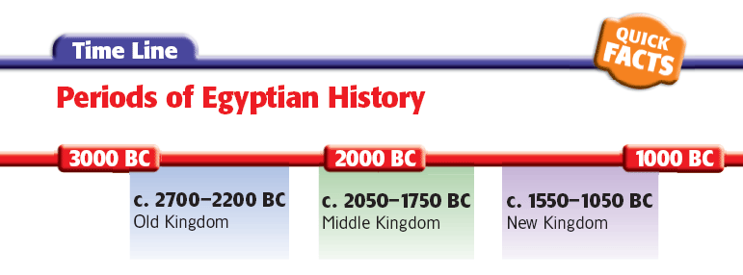
The Middle and New Kingdoms
The Big Idea: During the Middle and New Kingdoms, order and greatness were restored in Egypt.
Main Ideas
- The Middle Kingdom was a period of stable government between periods of disorder.
- The New Kingdom was the peak of Egyptian trade and military power, but their greatness did not last.
- Work and daily life were different among Egypt’s social classes.
Main Idea 1:
The Middle Kingdom was a period of stable government between periods of disorder.
- Following a period of competition for power between the __________ and the ___________, the ___________ Kingdom began.
- Egypt fell into disorder around 1750 BC. A group called the _________ invaded and ruled the region for _______ years.
- The Egyptians fought back, and Ahmose of Thebes declared himself ________ and drove the Hyksos out of Egypt, beginning the _________ Kingdom.
Main Idea 2: The New Kingdom was the peak of Egyptian trade and military power, but their greatness did not last.
- Fearing future ________, the Egyptians took control of all possible invasion _________ into the kingdom.
- Egypt took over vast lands and was the leading __________ power in the area.
- Egypt became _________ because of the __________ it conquered.
Growth and Effects of Trade
- Conquests brought __________ into contact with distant lands, and trade routes, or _______ followed by traders, developed.
- Queen Hatshepsut encouraged trade and used the ________ to support the _______ and architecture.
- Led by Ramses the Great, Egypt ________ invaders for many years, leaving their empire diminished.
Main Idea 3: Work and daily life were different among Egypt’s social classes.
- The complex society required people to take on many different kinds of _________.
- _________ life was very important in Egyptian society, and most Egyptians lived in their own homes.
  - _________ had many legal rights, including owning property, making contracts, and divorcing their husbands.
Egyptian Jobs
- Scribes: Few people were more respected than _________. They did not have to _______ taxes, and many became wealthy.
- Artisans, Artists, and Architects: These jobs required advanced _____ and were also very admired in Egypt.
- Merchants and Traders: Although trade was important, _______ held these positions. Some had to travel very long distances to ________ and _________ goods.
Additional Egyptian Jobs
- Soldiers: Egypt created a permanent __________ that offered soldiers a chance to ________ in social __________ and receive land as payment.
- Farmers and Other Peasants: This group made up the vast majority of the _____________. They grew crops to support their ____________ and to pay _____________.
- Slaves: Slaves were usually ________ or __________ of war. They had some legal rights, however.
Egyptian Achievements
The Big Idea: The Egyptians made lasting achievements in writing, architecture, and art.
Main Ideas
- Egyptian writing used hieroglyphics.
- Egypt’s great temples were lavishly decorated.
- Egyptian art filled tombs.

Main Idea 1: Egyptian writing used hieroglyphics.
- Hieroglyphics was the Egyptian _____________ system.
- Egyptians learned to write hieroglyphics on papyrus, a long-lasting, ____________-like material made from _______________.
- Scribes wrote on papyrus using brushes and _______________.
- Historians learned how to read hieroglyphics after discovering the Rosetta _____________ written in three languages.
-Hieroglyphics
-A later form of Egyptian (Demotic)
-Greek
Be able to identify on a map:
- The Nile

- Upper Egypt

- Lower Egypt

- Red Sea

- Mediterranean Sea

- Nile Delta

- Sinai Peninsula

- Nubia

- Kush

- Western Desert

- Eastern Desert

- Giza

